**SHRI J.H. BHALODIA WOMEN’S COLLEGE RAJKOT**

**A PROJECT REPORT ON**

**“VIMAL ENGINEER BEARING PVT.LTD.”**

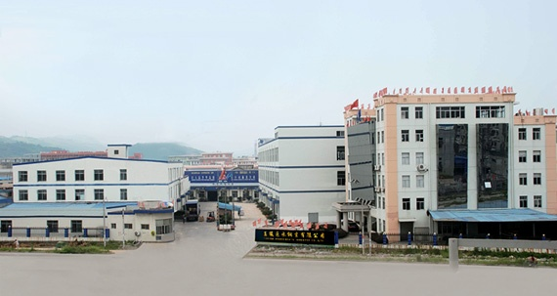

**Prepared by:**

**Kavathiya Skruti J.**

**B.B.A. Sem. II**

**Academic Year: 2017-2018**

**Roll No. : 43**

**Guided by:**

**Dr.N.M.Kanani**

**Submitted to:**

**Saurashtra University Rajkot**

**PREFACE**

Industrial visit is also important aspect in management course. The theoretical knowledge and classroom discussion is not enough for management student. For the knowledge about practical view points, problem, opportunities and situation of industrial unit’s practical studies is necessary.

“Education begins where classroom teaching ends.”

So, this context Industrial visit program during our **academic year 2017-2018.** I have visited "vimal eng.com. **Pvt. Ltd.”** and also I have tried to prepare this report with the best of my knowledge and ability.

Acknowledgment

First of all I would like to thank the promoer and HR Manager of the company for giving me proper information about the company. I would like to thank principal of shree J.H.Bhalodia women's college for providing me an opportunity to work on this project.

I am grateful to my Dr.N.M.Kanani for give me the guidance for prepare the project report on the "vimal engineering company pvt. ltd."

I would also like to thanks a my family and friends for leading their support throughout the project report.

Date: Your's Faityfully

Place:Rajkot Skruti Kavathiya

**DECLARATION**

I undersigned Skruti KavathiyaThe Student of B.B.A.-sem-II here by declare that the project work presented in this report is my own work and has been carried out under the supervision and guidance of Dr.N.M.Kanani of J.H. Bhalodia women's college-Rajkot.

This work has not been previously submitted to any other university for any examination.

Date: place:Rajkot

Signature. (Skruti Kavathiya)

.

**INDEX**

|  |  |  |
| --- | --- | --- |
| **No.** | **Section** | Page no. |
| 1. | **General information** | 8 |
|  | A. Industry introduction | 9 |
|  | Growth rate of the company | 10 |
|  | Top Five Units | 11 |
|  | B.Information about company | 12 |
| B.1 | Establishment and History of the units | 12 |
| B.2 | Location Map | 13 |
| B.3 | Company Profile | 14 |
| B.4 | Size & form of the Organization | 15 |
| B.5 | Mission, Vision & Goals | 16-17 |
| B.6 | Promoters & managing group | 18 |
| B.7 | Organization Structure | 19 |
| B.9 | Contributio of firm in the industry | 20 |
| **2.** | Production Department | 21 |
| 2.1 | Introduction | 22 |
| 2.2 | Types of products | 23 |
| 2.3 | Raw material and sources of raw material | 24-25 |
| 2.4 | Manufacturing process | 26-28 |
| 2.5 | Plant lay out | 29-30 |
| 2.6 | Installed and utilized capacity | 31 |
| 2.7 | Quality control and inspection | 32 |
| **3.** | **Human resources department** | 33 |
| 3.1 | Introduction | 34 |
| 3.2 | Employees details and classification | 35 |
| 3.3 | Time keeping system | 36 |
| 3.4 | Employees benefits and services | 37 |
| 3.5 | Industrial relations | 38 |
| **4.** | **Marketing Department** | 39 |
| 4.1 | Introduction | 40 |
| 4.2 | Products of the company | 41 |
| 4.3 | Distribution management | 42-43 |
| 4.4 | Promotion | 44 |
| 4.5 | Competitors details | 45 |
| **5**. | **Financial Department** | 46 |
| 5.1 | Introduction | 47 |
| 5.2 | Source of finance | 48 |
| 5.3 | Reserve and surplus | 49 |
| 5.4 | Loans | 50 |
| 5.5 | Sales local and Export review of last capital budgeting decision | 51 |
| 5.6 | Profit | 52 |
| 5.7 | Dividend | 53 |
| **6.** | **Future plans** | 54-55 |
| **7.** | **Suggestions** | 56-57 |
| **8.** | **Bibliography** | 58-59 |
| **9.** | **Conclusion** | 60-61 |



**A.Industry Introduction**

The bearing industry is fairly concentrated, with the top five player contributing over 90% of overall turnover. SKF India is the leading player in the market followed by FAG bearings, NBC bearings and Timken India. To meet growing customer expectations, most of the bearings manufacturers have regularly invested in modern manufacturing technology and have taken a number of initiatives to strengthen them competitive advantages by partnering with costumers with a focus in application engineering and R&D to develop advanced products. The report entitld "Indian bearing markets an analysis” Provided an Insight into the bearing sector in India with a special focus on sub- segments.

Like ball bearing and roller bearings. The report also includes the production, market value, segmentation on various parameters and distribution structure of overall bearing sector it also discusses key growth drivers. Trends and major challenges faced by bearings industry in India.

**Growth rate of company**

The bearings industry was estimated at Rs 12.5 billion inanized sector is estimated to have a share of 65 per cent of the market with imports accounting for about 30 per cent and the unorganized sector accounting for the rest. According to industry sources, the Indian bearing industry has been growing at a CAGR of 8.2 per cent in the last six years. In this, automotive segment accounts for 45 per cent of the revenues, which amount to Rs 1,350 crores and the remaining 55 per cent of revenues are being contributed by industrial demand. In the automotive bearings market, the organized segment manufacturers cater to 50 per cent of the demand.

**Top five units of the company**

|  |  |
| --- | --- |
| **Sr. No**. | **Company Name** |
| 1 | SKF India,  Pune, India. |
| 2 | FAG bearing India ltd.  P.O. maneja, Vadodara. |
| 3 | NRB  Waluj, Aurangabad. |
| 4 | TIMKEN  39-42, ele. City,  Phase-2  Karnataka, bengoler. |
| 5 | ABC  Bharuch, Gujarat. |

**B.INFORMATION ABOUT COMPANY**

**1. ESTABLISHMENT & HiSTORY OF THE UNIT**

**"VIMAL ENGINEERING BEARING PVT. LTD”** was established in **1994**, for manufacturing of ball bearing and taper roller bearing with indigenous plant & machinery. Slowly the machinery upgraded to import use machine for Better higher production.

Within the period of 13 years the company has established its name in the replacement markets well as original equipment manufacturers.

**“VIMAL ENGINEERING BEARING PVT. LTD”** is leading manufacturer of bearing for industrial and automotive application. **“VIMAL ENGINEERING BEARING PVT.LTD”**Is very successfully and regularly been supply Throughout the country.

**2. LOCATION MAP**

**“Vimal engineering bearing Pvt. Ltd.”**

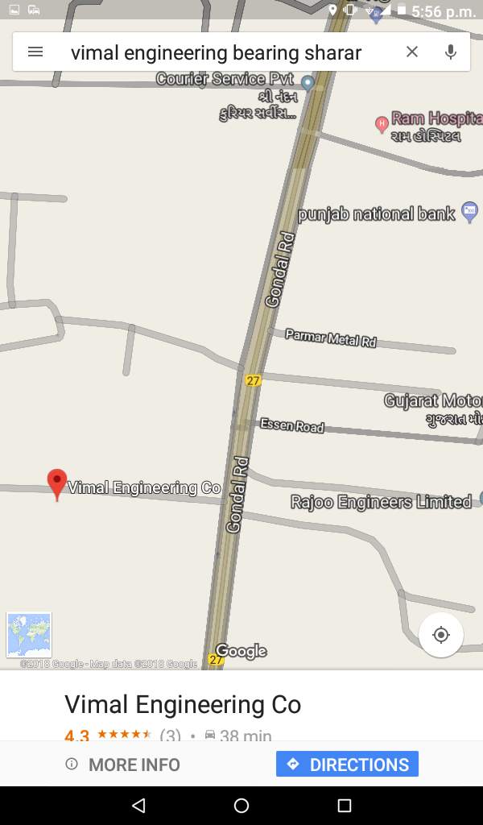

**3.Company Profile**

**Company detail**

|  |  |
| --- | --- |
| **Name** | **“Vimal Engineering bearing Pvt. Ltd.”** |
| **Address** | **Plot-4,Vimal house,Surve no.30,Shapar Rajkot-360024** |
| **Establish** | **1994** |
| **E-Mail** | **[vimalbearing@yahoo.co.in](mailto:vimalbearing@yahoo.co.in)** |
| **Contact person** | **Adit N. Padaliya** |
| **Tele. No.** | **(02825) 220223-231923** |
| **Labors** | **120 (one hundred twenty)** |
| **Turn over** | **80 lakh above** |
| **Marketing manager** | **Adit N. Padaliya** |
| **Finance manager** | **GirishbhaiPadaliya** |
| **Form of the unit** | **Partnership** |
| **Size of the unit** | **Medium scale industry** |
| **Weekly off** | **Wednesday** |
| **Banker** | **HDFC & BOB** |

**4.Size&Form of the Organization**

**Size of the unit**

Industries are classified According to their investment as

1. Small scale Industry
2. Medium scale Industry
3. Large scale Industry

**“VIMAL ENGINEERING BEARING PVT.LTD”**

Investments 5Crore so it is “**Small scale industry”.**

**Form of organization**

In these world there of firm or organization like,

* Private company
* Public company
* Co-operative society
* Sole trader
* Partnership firm
* Government company

**“VIMALENGINEERING BEARING PVT.LTD.Partnershipfirm.**

**5.Mission, vision & goals of the firm**

* **Mission** :-
* To provide high performing quality products and to innovate new technology and to expand the sales network in abroad also in due course of time provide good services
* To maintain standards
* To acquire global capabilities
* **Vision:**
* Understanding customers requirement and reduce nonconformity
* Minimizing waste and reduce cost.
* Adopting training program new technologies and for continuous improvement for year training program.
* Maintaining the quality of manufacturing product at any cost.
* **Goals:**
* Reasonable Profit
* More Customers
* Improve Company Reputation
* Maintain Product Standard.

**6.Promoters & managing group**

**Promoters: Bhikhubhai**

**Existing managing group:-**

|  |  |
| --- | --- |
| **Manager** | **Manager name** |
| Production Manager | Ashokbhai Patel |
| HR manager | Bhikhubhai |
| Marketing manager | Aditbhai N. Patel |
| Financial manager | Girishbhai |

**7.Organization structure**

**jhjhjkkk**

Director

B. O. D.

Production Department

Marketing Department

HR

Department

Finance Department

HR

Manager

Financial

Manager

Marketing Manager

Production Manager

Engineer

Sales Executive

Accountant

Employees

quality control manager

Supervision

**8.Contribution of firm in the Industry**

Contribution means how much support to industry in production.

The contribution of units to the industries is including the unit, which is helpful to other industries or other depending on particular industries. It also includes export of the industries.

Its contribution in bearing industry is 1.1%.

**PRODUCTION**

**DEPARTMENT**

.

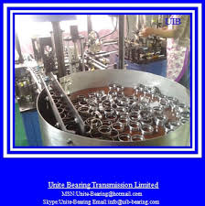

**1.Introduction**

Involves making final goods for consumption by using the source of production that is Land Labor capital and entrepreneur.

Production department is one of the most important department of the company production can be defined as “procedures is nothing but what a seller has to sales and what a buyer has to buy”

Production management is the process of planning organizing directing and controlling the activities of the production function is the conversion of row material in to finished production.

**2. Types of product**



* Taper roller bearing
* Ball bearings
* Needle roller bearing
* Spherical roller bearing
* Cylindrical roller bearing
* Clutch release bearing

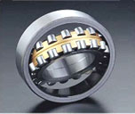

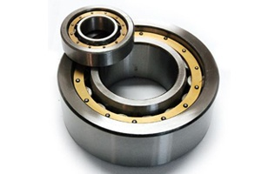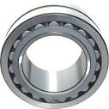

  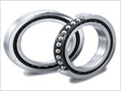 

**3.Raw material & Sources of Raw Material**

**Raw-Material**

The raw material is produced only from customer’s approved source. The raw material is passed through strict quality tests like metallurgical and chemical taste by qualified and experienced metallurgists and chemists. After the laboratory approval, the raw material is stored heat wise, size wise, supplier wise , with color code in bin and is also forwarded for further processes.

**“Vimal Engineering Bearing Pvt. Ltd.”** In raw materials is under:

* **Carbon steel SAE 521000**
* **EN-8**
* **Cages of bearing**
* **coal**
* **Iron steel**
* **EN-31**

**Sources of row-material**

**“Vimal Engineering Bearing Pvt. Ltd.”** Getting raw materials from various place which is use in production process. This company getting raw materials from Shiv Shakti steel, phonier Steele etc. So, after getting raw materials company will start to produce various goods.

**4.Manufacturing Process**

The process of “**VIMAL ENGINEERING BEARING PVT. LTD.”** Cup corn involves following steps.

Forging of Steel

Annealing

Rouge Turning

Final Turing Work

Hardening

Grinding

* **Forging of Steel** :

The Steel is purchased & gets forged. Forged material is hard.

* **Annealing :**

It is second process and it requires annealing for 36 hours. It makes material soft so that turning of steel can be made. It helps in turning.

* **Rough Turning :**

Here rough turning of inner and outer of cup corn bearing is made.

* **Final Turning Work :**

We gives the master series of different item i.e. the exact shape & design of different cup corn bearing and the required measurement of bearing for which turning on job work to be made by job worker. Based on the close dimension of the original master the final to turning of cup corn bearing is made according to the precision.

* **Hardening :**

It is known as heat treatment & it helps the hardening of cup corn from inside. As per international standard the inner hardness requirements are 58 to 62.

* **Grinding :**

This is the main &final in which we are involved. It is the making of final bearing & its required four types of grinding machine i.e. surface machine, centre less machine, internal machine, and external machine. As per the industrial experience and on the basis of capacity of the plant & machinery, the production capacity of the final grinding machines per day one shift is estimated to be 500 bearing per day.

**5.Plant Lay Out**

The arrangement of all machinery in the workshop are so as to get maximum output from its;

The office of the quality controller opposite of all machine so, quality controller has directly able to see the original work of the employees, it is very carefully arranged its work facilities and personnel for done work effectively and efficiently

**Detail of plant &Machineries**

There are various types of machines are required in the Bearing part. The whole lists of the machines required are given below. The machines are required in order to finish the product speedily.

| **Sr. no.** | **MACHINES** |
| --- | --- |
| **1** | **Line cutting machine** |
| **2** | **Drill machine** |
| **3** | **Rolla- den machine** |
| **4** | **Welding machine** |

**6.Installed & utilized capacity**

1. **installed capacity:-**

* 2000 per day.
* 60,000 per month
* Yearly Installed capacity is

2,000 x 300 day= 6, 00,000

**2) Utilized capacity:-**

* 80% i.e. Per day.
* 48,000 per month
* Yearly Utilized capacity is

1,600x 300 days= 4, 80,000

|  |  |  |
| --- | --- | --- |
| **Particular** | **Installed capacity** | **Utilized capacity** |
| Per Day | 2000 | 1600 |
| Per month | 60,000 | 48,000 |
| Yearly | 6, 00,000 | 4, 80,000 |

**7.Quality control & Inspection**

Quality control is the best user for business because; Quality is reputation of the unit. Sample testing for chemical & physical analysis etc. are done by outside agency on regular basis.

Quality control department **of “VIMAL ENGINEERING BEARING Pvt. Ltd.”** checks the quality of the products with the help of equipments. Quality person checked out any defect in product

.

* To achieve 100% on time delivery.
* To achieve no defect in supplied product of customers.
* To achieve 100% satisfaction on the customers.To reduce customers complaints up to zero.

**HUMAN RESOURCES DEPARTMENT**



**1.Introduction**

Human department involves procedure and practice through which human resources are managed to workers the attainment of the individual social and organizational goals .Personnel department involves determining the organizational human beings need, determining and selecting the best employee to work.

In **“VIMAL ENGINEERING BEARING PVT. LTD”** The management of personnel is done by personnel manager. The activities of recruitment selection, wages, training etc. are performed by the department manager

**2.Employee details & classification**

In **“VIMAL ENGINEERING BEARING PVT. LTD.”** the total number of employee is 120. Their classification is given below:

|  |  |
| --- | --- |
| **Employees** | **No.of employees** |
| Skilled | 40 |
| Unskilled | 80 |
| Total | 120 |

**3.Time keeping system**

* **For managerial staff :**

|  |  |
| --- | --- |
|  | **Time** |
| Shift | 8:00 a.m. to 8:00 p.m. |
| Recess | 1:00p.m. to 2:00 p.m. |

* **For workers :**

|  |  |
| --- | --- |
| **Shift** | **Time** |
| I. | 8:00 a.m. to 8:00 p.m. |
| II. | 8:00 a.m. to 8:00 p.m. |

**4.Employee Benefits & Services**

The following are the facilities provided by the **“VIMAL ENGINEERING BEARING PVT. LTD.”** unit:

* **Canteen Facility:**

Basic necessities are provided to the employees at factory while at offices there is tea and coffee canteens.

* **Safety Facility:**

The workers working at factory are provided group insurance and safety facilities.

* **Bonus:**

Bonus is provided to the employees at Diwali.

* **Allowances:**

Employees are also provided medical and educational allowances.

**5.Industrial Relations**



Industrial relations are the relationship between employees and employers within the organizational settings the field of industrial relation looks at the relationship between manager and workers , particularly groups of workers represented by a union industrial relations are basically the interactions between employers and the governments and the institutions and associates through which such interactions are maintained .In **“Vimal Engineering Bearing Pvt. Ltd.”** Industrial relations are the relationship between employees and managers are good.



**1. INTRODUCTION**

“Marketing research is also the application of scientific principles and observational, experimental, historical and survey method in careful search for more accurate knowledge of consumer & market behavior, so that more effective marketing and distribution may be developed.”

Any industry is established to produce certain goods & to get reward by selling these goods. This selling process can be made easy by sales & marketing department. Thus this two department must exist in the organization.

**2.Products of the company**

**MACHINES**

**Line cutting machine Drill machine** 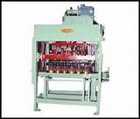

**Welding machine Rolla-den machine** 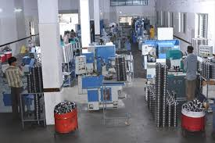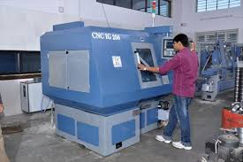

**3.Distribution Management**

**“VIMAL ENGINEERING BEARING PVT. LTD.”** Distribution channel is as under:

**Distribution channel**

Manufacturing of company

Distribution/dealers

Subdealers/retailer

Consumer

**Sales of last 5 years**

**“VIMAL ENGINEERING BEARING PVT.LTD.”** Had last 5 year’s sales

| **Year** | **Rs in Crore** |
| --- | --- |
| 2011-12 | 1.65 Crore |
| 2012-13 | 1.63 Crore |
| 2013-14 | 1.66 Crore |
| 2014-15 | 1.68 Crore |
| 2015-16 | 1.67 Crore |

**4.promotion**

**Promotion strategies**

**A)Advertising:**

**“VIMAL ENGINEERING BEARING PVT.LTD.”** The Medias of advertisement of

* **Wall painting**
* **Pamphlets**
* **Banners**

**B)Sales Promotion:**

Promotion is an important marketing mix tool, it includes all the activities that the company. Undertakes to communicate its products advantages and other information about the company and to influence the customers to buy them promotion involves.

The Medias of sales promotion of **“VIMAL ENGINEERING BEARING PVT. LTD.”**

* Personal Selling
* Publicity

**5.competitors Details**

In a life there is competition because there are producers of similar goods and same product so there is competition about price, product, quality and some more things so there is very tough competition

.

**Competitors:-**

* **GALAXY bearing**
* **APPLE bearing**
* **Sheer JOGI bearing**
* **VASTUPAL bearing**
* **RAVI TECHNO FORGING PVT.LTD.**

**FINANCIAL DEPARTMENT**



**1.Introduction**

**“Finance is the life blood of business”**

Finance management is that managerial activity which is concerned with planning and controlling of the firm financial resources. Thus finance covers financial planning, forecasting of cash receipts and allocation of funds and financial control.

As regards **“VIMAL ENGINEERING BEARING PVT.LTD.”** It is very good financial management which is operated by its manager. In this unit finance department is separated and due to its good and efficient financial policies the company can achieve the objectives which are proposed.

**2.Sources of finance**

In our life we get money though our work means earning but for earning we want some money to invest so in organization there is also same process. They want also money to invest in business. We involve in source of finance own capital borrowed capital, share capital, debenture.

Like these **“VIMAL ENGINEERING BEARING PVT. LTD.”** has a source of finance it is a bank and also its own capital and also lone.

HDFC bank

BOB bank

Their bank fund is 50% & also own fund is 50%.

**3.Reserve and Surplus**

| **Reserve & Surplus** | | |
| --- | --- | --- |
| **Particulars** | **Rs.** | **Rs.** |
| **Capital Reserve :**  **Subsidiary**  **Investment Allowance**  **Reserve** | **7,57,344**  **3,72,300**  **8,28,852** | **6,82,344**  **3,72,300**  **9,43,866** |
| **As per balance sheet** | **19,58,496** | **19,98,530** |

**4.Loans**

**Capital structure details**

Capital structure of **“VIMAL PRECISION BEARING PVT.LTD.”** Is a follow:

| **Capital** | **Rs.** |
| --- | --- |
| Borrowed Capital | 2.5 Crore |
| Owned Capital | 2.5 Crore |
| Total | 5 Crore |

Total investment of **“VIMAL ENGINEERING BEARING PVT. LTD.”** is 5 Crore.

Loan plays an important in any business or firm, when the firm or business is having security of capital or the firm wants to increases its production loan is taken.

Vimal engineering bearing take loan from bank of HDEC Bank or bank of baroda to develop the company.

**5.sales Local and Export Review of last capital budgeting decision**

**TARGET AND ACTUAL SALES**

**Target: “VIMAL ENGINEERING BEARING Pvt. Ltd. ”**target are 1,05,00,000

**Actual sales: "VIMAL ENGINEERING BEARING Pvt. Ltd.”**An actual seal is 85% of total production capacity.

Some basic information about of Bearing is:

* Daily Scale:

Daily sales of bearing are approximately 12 lacks prices.

* Sales per annum:

Annual sales of bearing is generally 1 months or it may be extended to 35 to 40 days.

* Discounts allowance:

Discounts or allowance to customers depends on quantity demanded and terms of payment.

* Taxes and duty:

Sales tax -4% of value

Excise- 16% on product

Central sales tax -4%

**6. PROFIT OF THE UNIT**

Profit is the financial benefit that is realized when the amount of revenue gained from a business activity exceeds the expenses, costs and taxes needed to sustain the activity.

Profit is motivator of any business unit. Without profit none of the industry can stand in the market. The profit of the Vimal Engineering Bearing Pvt. Ltd.” Of last five year is as follows.

| **Year** | **Profit** |
| --- | --- |
| 2011-2012 | 2, 92, 75, 000 |
| 2012-2013 | 3, 20, 82, 000 |
| 2013-2014 | 2, 43, 63, 000 |
| 2014-2015 | 3, 78, 35, 000 |
| 2015-16 | 4, 55, 32,000 |

**7.Dividend**

Dividend distribution depends on the companys profit if companys profit is good than shareholder will get good dividend & if not then they will wont get good dividend.

As company had good profits in the year (2002-03) company had also given 100% dividend.

**Analysis of overall financial position of the firm**

**Balance sheet**

|  |  |  |  |
| --- | --- | --- | --- |
| **Liabilities** | **Amount** | **Assets** | **Amount** |
| Capital:  Own capital:  Borrowed capital:  Net Profit  Current Liabilities:  Creditor | *2,50,00,000*  *2,50,00,000*  *80,00,000*  *1,60,00,000*  *5,00,00,000* | Fixed assets :  Land:80,00,000  - Dep.: 4,00,000  5%  Machinery:1,45,00,000  -Dep. 10% : 14,50,000  Building: 1,02,00,000  -Dep. 10%;10,20,000  Current assets:  Debtors: | *76,00,000*  1,30,50,000  78,30,000  91,80,000  2,10,00,000  6,80,40,000 |
|  | ***12,40,00,000*** |  | ***12,40,00,000*** |



**“VIMAL ENGINEERING BEARING PVT.LTD.”** Is following points for future plans,

* They are going to take stapes to expand marketing department in their own unit.
* They want to expand their unit internationally.
* To increase the production.
* To develop each area of quality.
* Expansion of business.





**Suggestion**

Actually we are just students and to write something as a part of suggestion. It is not our capacity to suggest the company, but as a part of B.B.A. student and also for our project work so, as a student, I have to work as a report.

* My suggestion to them is that the unit should have tried to give to some more motivation employees. So that they work with enthusiasm.
* And secondary is there they should have tried to give more security facility to their workers.





In preparing project report I have referred the following books:

|  |  |  |  |  |
| --- | --- | --- | --- | --- |
| **Sr no.** | **Name of the Book** | **Author** | **Edition**  **year** | **Publication** |
| 1) | Human Resource Management | R.Viswanathan&R.Krishnamoorthy | 2011 | Himalaya publishing house |
| 2) | Marketing Management | Dr.K.Karunakaran | 2009 | Himalaya publishing house |
| 3) | Financial Management | M.Y.Khan&P.K.Jain | 2012 | Tata McGraw Hill Education Private Limited |
| 4) | Production & Operation Management | S.A.Chunawalla | 1997 | Himalaya publishing house |



**Conclusion**

After the study of whole unit, I conclude that the performance of this unit is very good. The company was still in its developing stage but the overall system that the company follows is very effective.

I got all information regarding channel to distribution which a necessary for us to know those all the required information about the company. Adit patel gave me the information of the company.

I wish **“VIMAL ENGINEERING BEARING PVT. LTD.”** will have great success in its future.